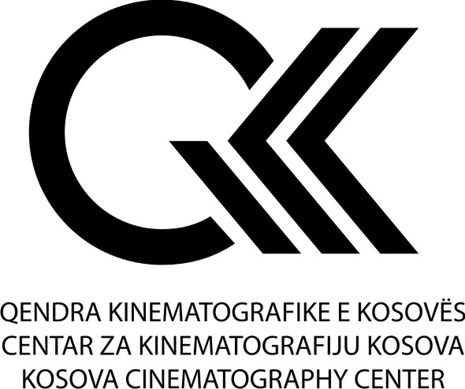

MEMORANDUM OF UNDERSTANDING
BETWEEN

KOSOVO CINEMATOGRAPHY CENTER
AND

EUROPEAN AUDIOVISUAL ENTREPRENEURS

Authorities

Kosovo Cinematography Center, Rr. UÇK Nr 273 10000 Prishtina, Republic of Kosovo (KCC)

And

European Audiovisual Entrepreneurs a.s.b.l., 238c, rue de Luxembourg, 8077 Bertrange, Luxembourg (EAVE)

Purpose of Memorandum

This Memorandum of Understanding regards the intent to cooperate in the field of providing audio-visual education to citizens of Republic of Kosovo into the European Audiovisual Entrepreneurs

Short overview of KCC

Kosovo Cinematography Centre (KCC) has been established in 2004 as an institution carrying attributed of a central cinematography institution of the Republic of Kosovo, which functions in subordination to the Ministry of Culture, Youth and Sports.
Kosovo Cinematography Centre aims to carry out policies in the area of cinematography that reflect public interest.

Short overview of EAVE

European Audiovisual Entrepreneurs, EAVE, is a professional training, project development and networking organization for audiovisual producers.
Working with a worldwide network of partners we are involved in programmes for producers in Europe, Russia, Latin America, the Arab world, Asia and Africa.
Founded in 1988, our objectives are to provide professional training opportunities and to bring producers from different regions of the world together with the aim of facilitating co-production relationships. We believe that the support of independent voices, creative imagination and culturally driven companies within the global media industries is an urgent necessity in the 21st century. Through our work we aim to contribute towards the creation of strong networks of producers and to encourage the exchange of knowledge and skills, which will strengthen independent production across the world.

General Obligations:

This MoU is to confirm that KCC and EAVE have agreed to work together to create a scholarship for the citizens of the Republic of Kosovo on the following terms:

- EAVE should completely administer the scholarship including but not limited to advertising for, interviewing and selecting the candidates;

- EAVE should select the final candidate for the scholarship in a fair and impartial manner;

- The period of scholarship is 1 year;

- The amount of the scholarship is 6800,00 euros without a project and 7800,00 with a project plus the travel costs;

- KCC can pay fully or partly the scholarship for the selected candidates

- This MoU doesn't create a legal partnership between KCC and EAVE;

- KCC shall also draft an agreement-contract with scholarship recipients, which shall set out obligations of the scholarship beneficiaries regarding the development of the cinematography in the Republic of Kosovo;

- This MoU shall apply for an initial period of 3 years and continues automatically for another three years unless the parties decide otherwise.

- This MoU will enter into force on the date of its signing.

Date: ___ February 2020

Place: Berlin

Arben Zharku Kristina Trapp

Director, Kosovo Cinematography Center CEO, EAVE

