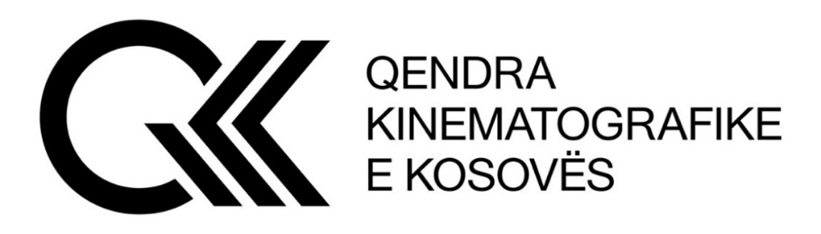

Kosovo Cinematography Center, based on Article 14 of Law No. 08/L-202
on Cinematography and Regulation (MCYS) No. 02/2023 on competitions and financial support of film and audio-visual works announces:

FEATURE DOCUMENTARY FILM COMPETITION (over 60 minutes)
Ref. No. KCC 02/2023

For subsidizing feature documentary film cinematographic projects.
All legal entities, local or foreign, registered in Kosovo as a film production business entity and previously registered with the KCC and who meet the conditions required by this competition have the right to participate in the competition.

I. The application is made online through the link www.qkk-rks.com, where, among others, the following are required:
1. Cultural test;
2. Budget;
3. Synopsis;
4. Treatment;
5. Directorial Concept;
6. CV of the main authors;
7. Two short films or one feature film by the director and two short films or one feature film by the producer (the link must be attached to the application);
8. Proof of application fee payment in the amount of €100.00 (one hundred euros);
9. Other relevant documents.

II. PARTICIPATION REQUIREMENTS

- To qualify for the competition, the participant in the competition, among others, shall apply with: the screenwriter, the producer, the director and the co-producers (if any), the number of KCC registration certificate, the budget and the CVs of main authors.
- Film houses that have failed to fulfill the contract with the KCC for previously awarded projects, do not have the right to participate.
- Film houses do not have the right to compete with more than three projects within the competition.

- The director and producer competing with a feature film project must have completed at least two short or one feature length projects.
- Projects that have started filming cannot apply to the competition, except for documentary films and post-production.
- Television films of different lengths and genres are not eligible for participation/application.
- Projects that have been rejected three times do not have the right to participate;

Note – according to Law on the prevention of conflict of interest: the employees of the Ministry of Culture, Youth and Sports and its subordinate institutions do not have the right to apply to the Competition.

The competition will be open from 20.12.2023 to 24.01.2024

Application fee payment method:
The payment receipt is obtained at the offices of the KCC.

